DBMS

Ex–2 DML Commands

Name:- K. DUSHYANT REDDY Reg No.:- RA1911033010029

Branch:- CSE-SE

AIM:

To implement DML commands to perform insertion of table, update and delete column.

COMMANDS:

1. INSERT – Used to add rows(tuples) in tables

Syntax-

Insert Single Value

INSERT INTO <table-name> VALUES(<column1> <value1>,…);

Insert Multiple Value

INSERT INTO <table-name> VALUES(‘<&column1>’, <&column2>’,…);

/

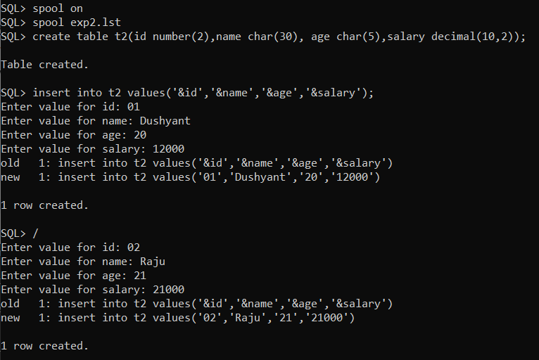 CODE-

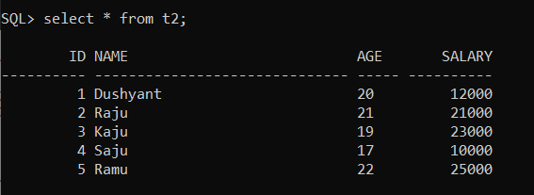

1. UPDATE – Used to change values in a row of existing tables.

Syntax-

UPDATE <table-name> SET <column name>=<value>;

CODE-

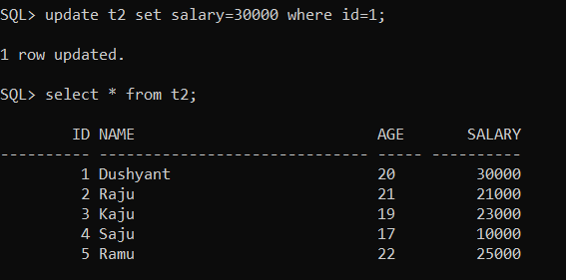

1. DELETE – Used to delete rows from the table.

Syntax-

DELETE FROM <table-name> WHERE <condition>;

CODE-

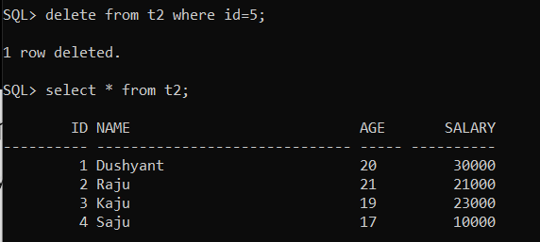

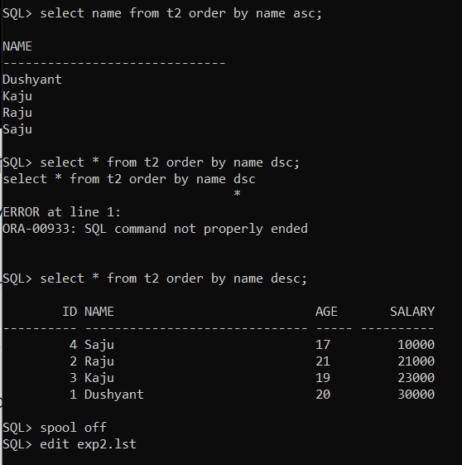

RESULT:

Thus, the DML commands have been executed successfully